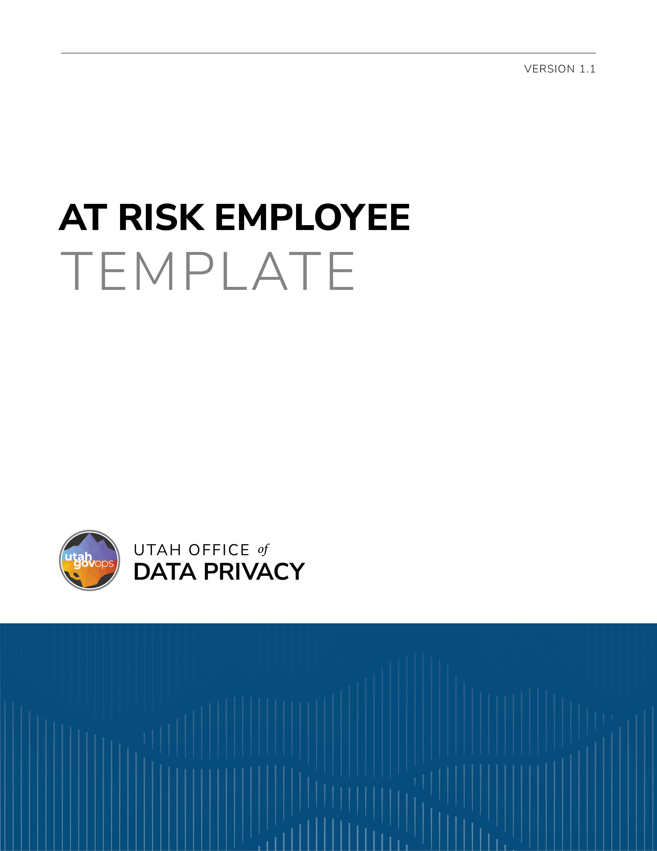

DISCLAIMER
This template is provided by the Utah Office of Data Privacy (ODP) as a resource to assist governmental entities. This template is intended to serve as general guidance and a foundational structure only. Governmental entities are responsible for reviewing, customizing, and adapting this template to ensure compliance with applicable laws, regulations, policies, and organizational needs.
The ODP makes no representations or warranties, express or implied, regarding the legal sufficiency or suitability of this template for any specific purpose. By using this template, governmental entities acknowledge and agree that the ODP is not liable for the use or modification of this template. This template is not legal advice and is not a substitute for consultation with legal counsel. Entities should consult with their own legal counsel before finalizing or executing a document based on this template.

REQUEST TO BE CLASSIFIED AS AN AT-RISK EMPLOYEE

Utah Code § 63G-2-303
An at-risk employee may request the employee’s personal information or the personal information of the employee’s family members be classified as private by completing this form. In addition, the highest ranking elected or appointed official in the employee’s chain of command must certify that the employee is at-risk.
Any personal data provided on or with this form will be used for the purpose of processing this request. If the personal data requested by this form is not provided, this request may not be granted. Personal data provided may be shared within the governmental entity to process the request, but it will not be sold. The personal data is included in Record Series # (include the number of the record series and a hyperlink).

Applicant’s name:
Address:
Email:
Phone number:

CERTIFICATION OF APPLICANT
- I hereby certify I am an at-risk employee because I am a current or former:
peace officer as specified in Section 53-13-102;
state or federal judge of an appellate, district, justice, or juvenile court, or court commissioner;
judge authorized by Title 39A, Chapter 5, Utah Code of Military Justice;
judge authorized by Armed Forces, Title 10, United States Code;
federal prosecutor;
prosecutor appointed pursuant to Armed Forces, Title 10, United States Code;
law enforcement official as defined in Section 53-5-711;
prosecutor authorized by Title 39A, Chapter 5, Utah Code of Military Justice; or
state or local government employee who, because of the unique nature of my regular work assignments or because of one or more recent credible threats directed to or against me, would be at immediate and substantial risk of physical harm if my personal information is disclosed.

- I am requesting my personal information or the personal information of the following family members be classified as private:

- I understand, acknowledge, and agree that:
- by submitting this form I may not receive official announcements affecting my property, including notices about proposed municipal annexations, incorporations, or zoning modifications;
- records containing personal information may be released if:
- I give written consent for the records to be released;
- a court orders release of the records; or
- my certified death certificate is provided;
- my voter registration records may be released to a qualified person under Subsection 20A-2-104(4)(n) according to the requirements of Subsection 20A-2-104(4)(o);
- I will be notified if a subpoena is issued for records containing my personal information and it is my responsibility to:
- authorize release of the record; or
- file a motion to quash with the court who issued the subpoena within 10 days from the date the subpoena was mailed to me;
- subpoenaed records will be released if I:
  - provide permission to the release records;
  - do not file a motion to quash; or
  - a court orders the release of the records;
- records containing my personal information will remain private until the earlier of:
- four years from today’s date; or
- one year after official notice of my death is provided; and
- I or a member of my immediate family if I deceased, may withdraw my request to have my personal information classified as private.

Dated:
Signature of applicant:

CERTIFICATION OF HIGHEST-RANKING ELECTED/APPOINTED OFFICIAL
Name of Certifying Official:
Title:
Employer:
Dated:
Signature of Highest-Ranking Official:

APPROVAL/DENIAL OF REQUEST
Your request to have records containing your personal information or the personal information of your family members be classified as private has been granted.

Your request to have records containing your personal information or your family member’s personal information be classified as private is denied because:
you have not provided all of the information required to be classified as an at-risk employee; or
you do not meet the requirements to be classified as an at-risk employee.

"Personal information" means the employee's or the employee's family member's home address, home telephone number, personal mobile telephone number, personal pager number, personal email address, social security number, insurance coverage, marital status, or payroll deductions.
“Family member" means the spouse, child, sibling, parent, or grandparent of an at-risk government employee who is living with the employee.
Utah Code § 63G-2-302.

