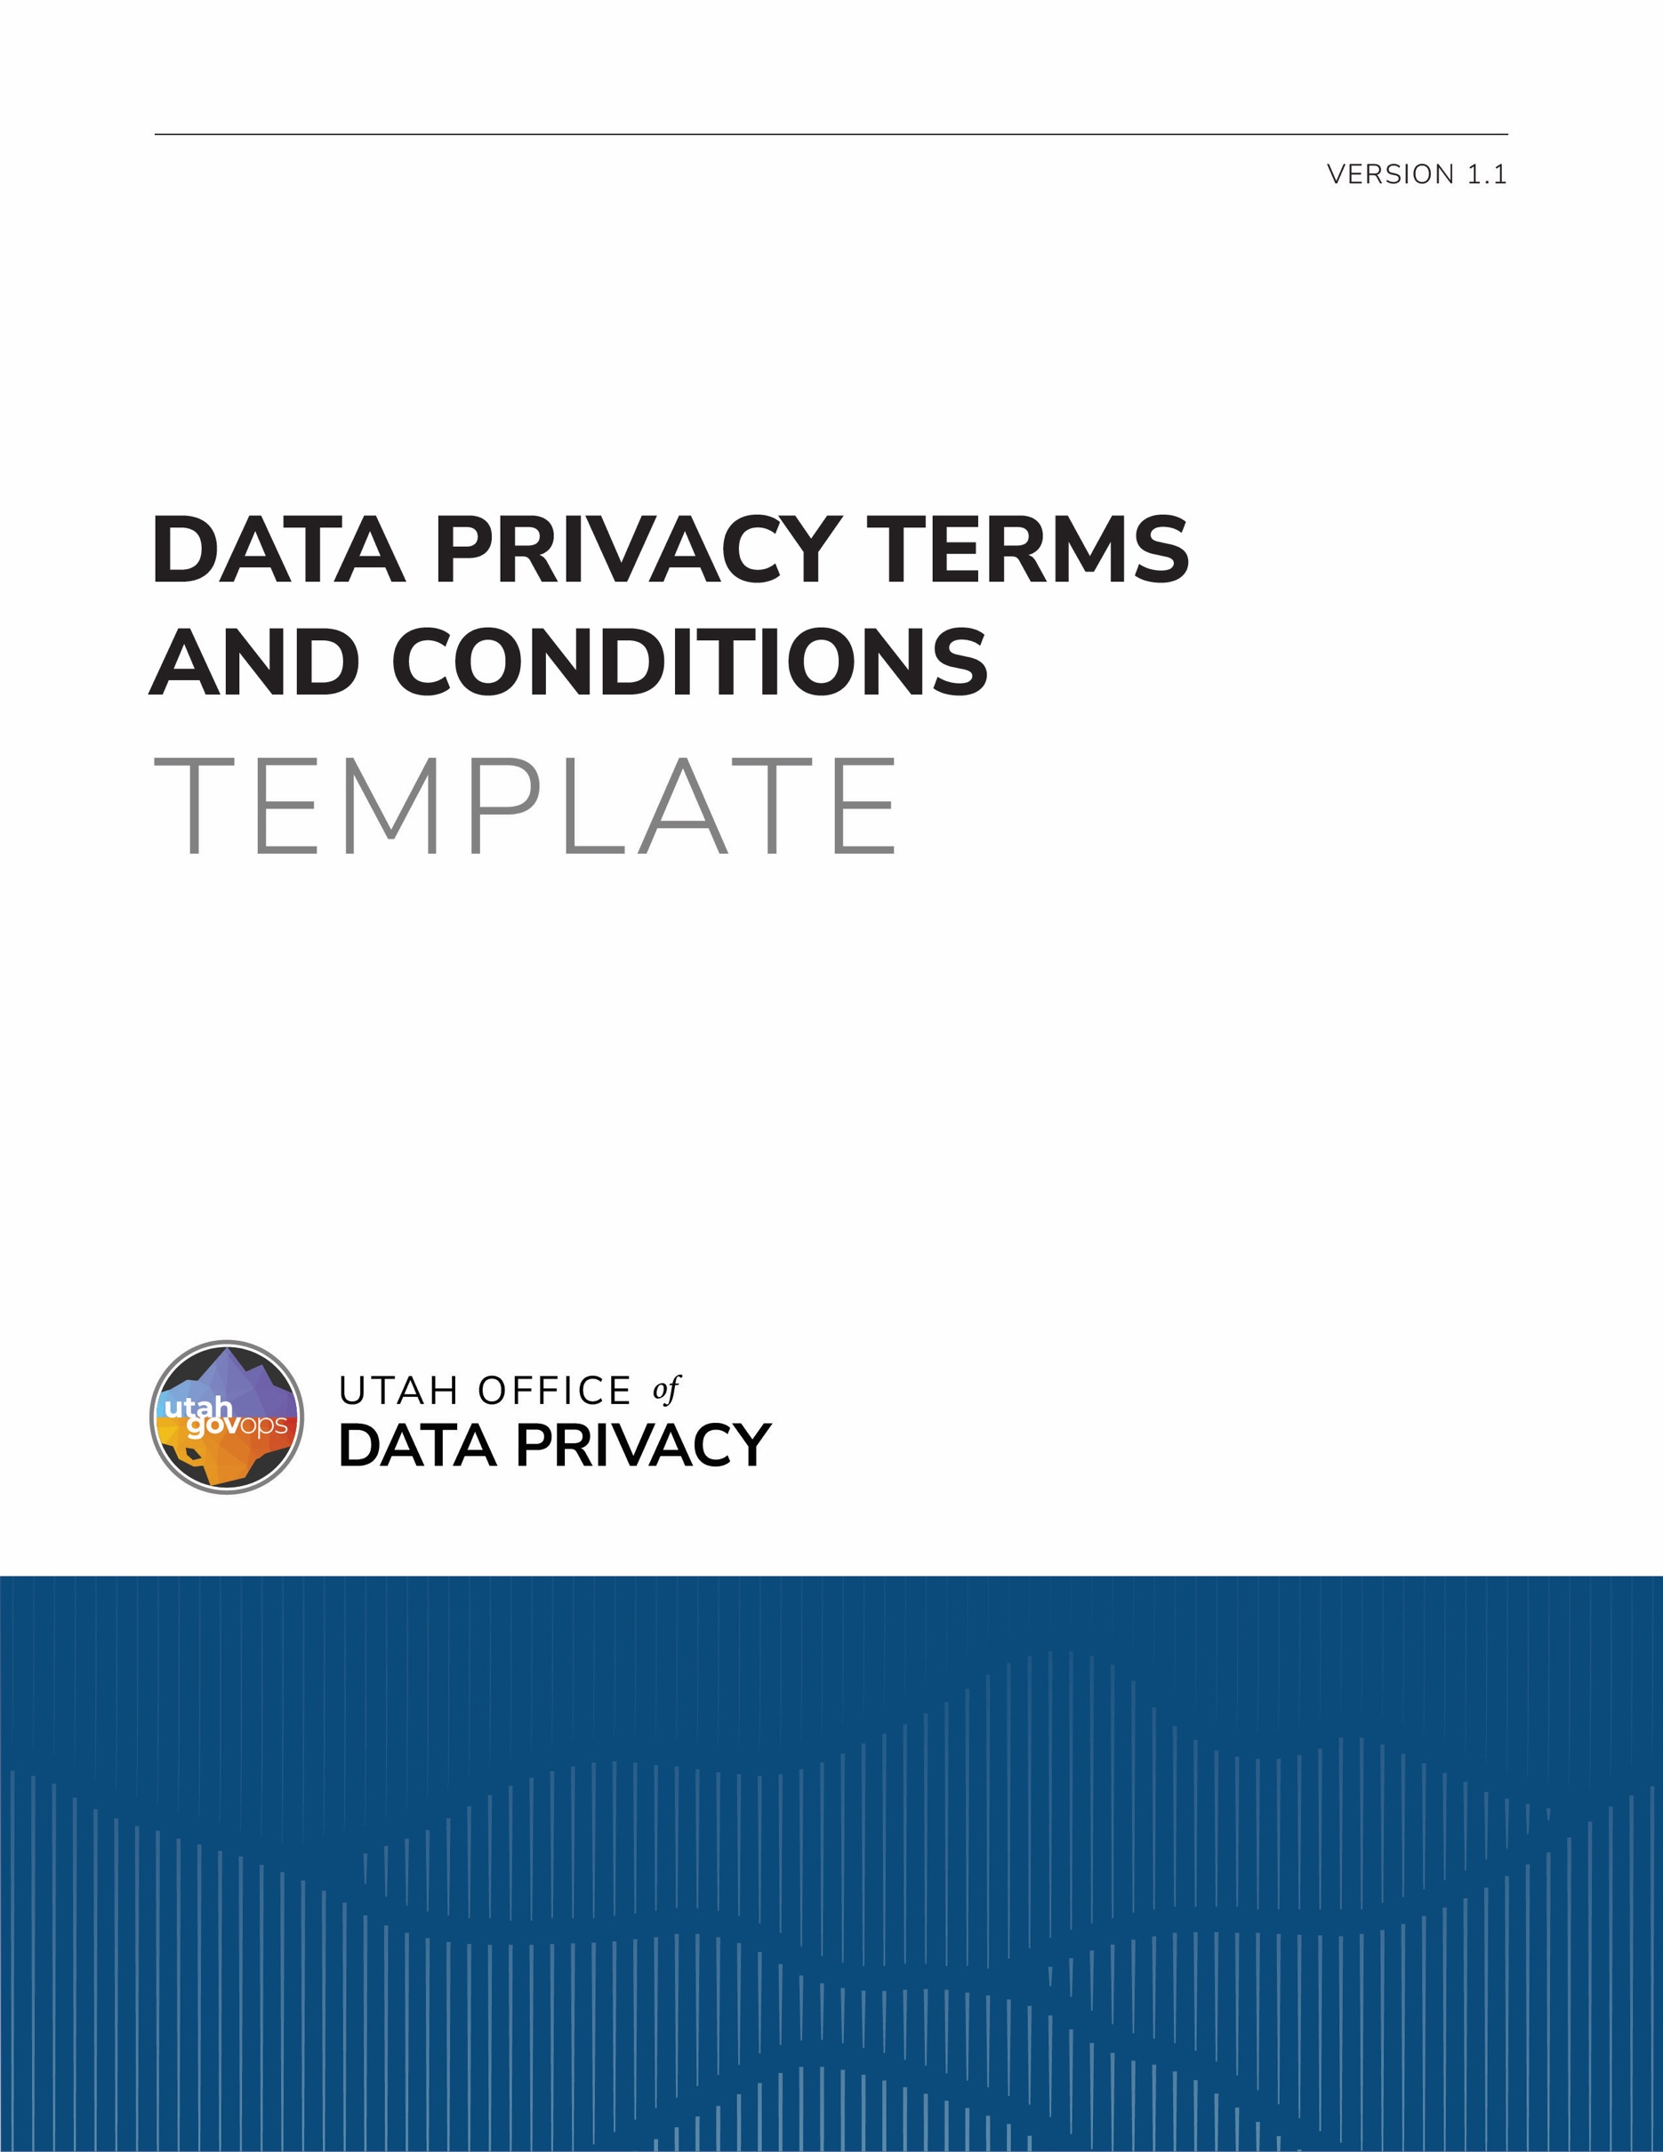

DISCLAIMER
This template is provided by the Utah Office of Data Privacy (ODP) as a resource to assist governmental entities. This template is intended to serve as general guidance and a foundational structure only. Governmental entities are responsible for reviewing, customizing, and adapting this template to ensure compliance with applicable laws, regulations, policies, and organizational needs.
The ODP makes no representations or warranties, express or implied, regarding the legal sufficiency or suitability of this template for any specific purpose. By using this template, governmental entities acknowledge and agree that the ODP is not liable for the use or modification of this template. This template is not legal advice and is not a substitute for consultation with legal counsel. Entities should consult with their own legal counsel before finalizing or executing a document based on this template.

These terms and conditions should be incorporated into the standard terms and conditions contained in a contract involving the processing of personal data. The contract should also prominently display a privacy notice which indicates: “Any personal data contained within this Contract is classified as a public record under Utah Code § 63G-2-301 and may be available to the public as provided by Utah Code § 63G-2-201”.

DEFINITIONS
As used in the Contract:
  - “Contractor” means a person who has entered into the Contract with [Governmental Entity] to process Data on behalf of [Governmental Entity] and includes the contractor’s employees, agents, or subcontractors; and
  - “Data” means all information, created, controlled maintained, owned, or that in any way originates from or on behalf of [Governmental Entity], including any copies, compilations, or derivatives of Data.

COMPLIANCE WITH DATA PRIVACY REQUIREMENTS
Contractor is subject to the data privacy requirements in the Government Data Privacy Act as described in Utah Code § 63A-19-401.4. Contractor shall comply with these data privacy requirements to the same extent as [Governmental Entity].

ACCESS AND DISCLOSURE OF DATA

Data is classified as a [public, private, controlled, protected, or exempt] record under [cite the legal authority that describes the classification]. Data is the property of the State of Utah as described in Utah Code § 63A-12-105. [Governmental Entity] retains authority and control over all Data processed in performance of the Contract.

[Governmental Entity] shall share the minimum amount of Data reasonably necessary for Contractor to fulfill the requirements of the Contract. Contractor may only access, use, and disclose Data as specified in the Contract.

Data may only be disclosed as authorized in the Contract. Contractor may not disclose Data in response to a request for records. Contractor shall refer to a person making a request for Data to [Governmental Entity] as required by Utah Code § 63G-2-204.

DISPOSITION OF DATA

Data is included in Record Schedule # [include the number and name of the record schedule] which governs the retention and disposition of Data. Contractor may not mutilate, destroy, damage, or dispose of Data except as described in this section.

Contractor shall return Data to [Governmental Entity] within thirty (30) days from the date the Contract is terminated or at any time upon written request by [Governmental Entity]. Any Data returned under this section shall be returned securely, regardless of where Data is stored or how Data is maintained. Data returned must be in the format as originally provided or in a format that is readily usable by [Governmental Entity]. Contractor will be responsible for paying the costs of returning Data to [Governmental Entity].

Instead of returning Data, [Governmental Entity] may require Contractor to dispose of Data, by means that ensure Data is permanently and irreversibly destroyed, if:
10.3.1.returning Data is not feasible; or
10.3.2.the Data’s retention period has expired.

INCIDENT RESPONSE

Contractor shall promptly notify [Governmental Entity] upon becoming aware of any unauthorized access, use, disclosure, modification, or destruction of Data, or any disruption to system operations involving Data. Contractor agrees to consult and cooperate with [Governmental Entity] regarding appropriate steps for remediation. Contractor agrees to take reasonable steps to mitigate any effects of such incident and limit any further use or disclosure of Data.

[Governmental Entity] is responsible for providing notice of any security incident or data breach as described in Utah Code § 63A-19-405. Contractor shall be responsible for complying with any other data breach reporting laws.

The party responsible for the security incident or data breach is responsible for:

providing notice of the security incident or data breach to affected individuals, as described in Utah Code § 63A-19-406; and

the cost of notifying affected individuals and any other remedial costs or damages.

