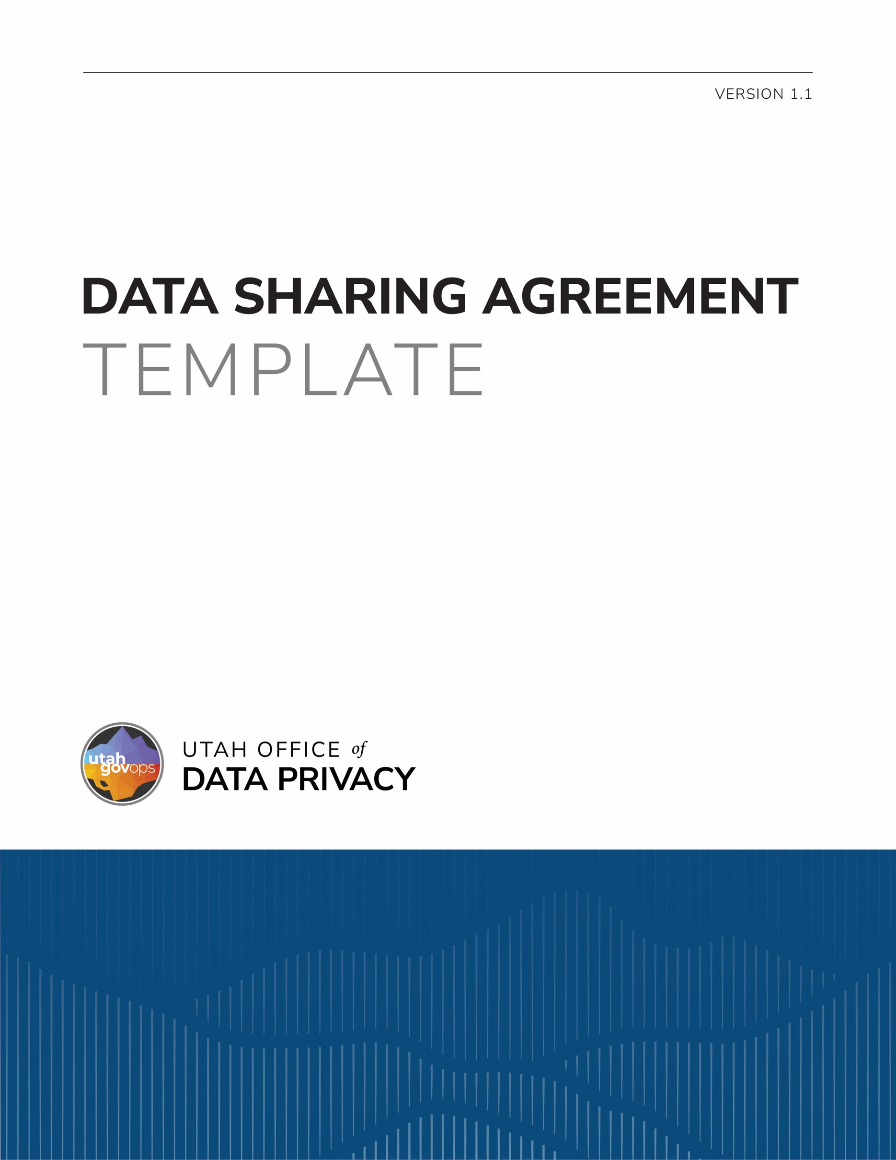

DISCLAIMER
This template is provided by the Utah Office of Data Privacy (ODP) as a resource to assist governmental entities. This template is intended to serve as general guidance and a foundational structure only. Governmental entities are responsible for reviewing, customizing, and adapting this template to ensure compliance with applicable laws, regulations, policies, and organizational needs.
The ODP makes no representations or warranties, express or implied, regarding the legal sufficiency or suitability of this template for any specific purpose. By using this template, governmental entities acknowledge and agree that the ODP is not liable for the use or modification of this template. This template is not legal advice and is not a substitute for consultation with legal counsel. Entities should consult with their own legal counsel before finalizing or executing a document based on this template.

DATA SHARING AGREEMENT BETWEEN [NAME OF SENDING ENTITY] AND [NAME OF RECEIVING ENTITY]
Any personal data contained within this Agreement is classified as a public record under Utah Code § 63G-2-301 and may be available to the public as provided by Utah Code § 63G-2-201.

DEFINITIONS
As used in the Contract:
  - “Agreement” means this data sharing agreement entered into by Receiving Entity and Sending Entity that establishes the terms and conditions under which Sending Entity shall share Data with Receiving Entity and how Receiving Entity may access, use, or disclose Data;
  - “Contractor” means a person who has entered into a contract or an agreement with a governmental entity to process Data on behalf of the governmental entity and includes the contractor's employees, agents, or subcontractors;
  - “Data” means [describe, in detail, the information to be shared] which was created by or originated with Sending Entity and includes all copies, compilations, or derivatives of Data;
  - “Receiving Entity” means [name of the governmental entity receiving Data from Sending Entity] and includes all of Receiving Entity’s employees, agents, and contractors; and
  - “Sending Entity” means [name of the governmental entity sending Data to Receiving Data] and includes all of Sending Entity’s employees, agents, and contractors.

AUTHORIZATION

Sending Entity is authorized by Utah Code § 63G-2-206 to share Data with Receiving Entity.

Sending Entity may also share Data with Receiving Entity as provided in [cite to any other legal authority which allows or requires Data be shared].

PURPOSE
  - Sending Entity shall share Data with Receiving Entity for the purpose of [describe, in detail, all of the reasons the Data is being shared].
  - Sending Entity may only share the minimum amount of Data reasonably necessary for Receiving Entity to fulfill Receiving Entity’s duties described in the Agreement.

PERMITTED USES
Receiving Entity may use Data for [describe all the ways in which Data received may be used].

ACCESS TO AND DISCLOSURE OF DATA
  - Data is classified as a [public, private, controlled, protected, or exempt] record under [cite the legal authority which describes the classification]. Data is the property of the State of Utah as described in Utah Code § 63A-12-105. Sending Entity retains authority and control over all Data shared with Receiving Entity.
  - Data may be accessed and used by Receiving Entity’s employees, agents, and contractors only if they have an actual and legitimate need to do so in the performance of Receiving Entity’s duties under the Agreement. Receiving Entity shall require any contractor who may have a need to access or use Data to agree in writing to:
    - the same terms and conditions as described in the Agreement; and
    - any other restrictions or conditions on the access to and use of Data Receiving Entity deems appropriate.
  - Data may only be disclosed as authorized in the Agreement. Receiving Entity may not disclose Data in response to a request for records. Receiving Entity shall refer a person making a request for Data to Sending Entity as required by Utah Code § 63G-2-204.

METHOD AND FREQUENCY OF DATA TRANSMISSION
[Describe how Data will be shared].

SAFEGUARDING DATA
  - Receiving Entity shall implement and maintain administrative, technical, and physical safeguards necessary to protect the confidentiality of Data and to prevent unauthorized use or access. These safeguards include, as appropriate and without limitation:
    - securing Receiving Entity facilities, data centers, paper files, servers, back-up systems, and computing equipment, including all mobile devices and other equipment with information storage capability;
    - implementing network, device application, database, and platform security;
    - securing information transmission, storage, and disposal;
    - implementing authentication and access controls within media, applications, operating systems, and equipment;
    - implementing logging and log retention of all transactions and system access;
    - encrypting Data stored on any mobile media and devices and computers/servers that allow remote access;
    - encrypting Data transmitted over public or wireless networks;
    - strictly segregating access to Data from information of other unauthorized customers so that Data is not comingled;
    - implementing appropriate personnel security and integrity procedures and practices;
    - providing appropriate privacy and information security training to Receiving Entity’s employees;
    - implementing appropriate privacy procedures and practices required by the Government Data Privacy Act found at Utah Code § 63A-19-101 et seq.; and
    - any other measures reasonably necessary to prevent unauthorized use or access.

INCIDENT RESPONSE
  - Receiving Entity shall promptly notify Sending Entity upon becoming aware of any unauthorized access, use, disclosure, modification, or destruction of Data, or any disruption to system operations involving Data. Receiving Entity agrees to consult and cooperate with Sending Entity regarding appropriate steps for remediation. Receiving Entity agrees to take reasonable steps to mitigate any effects of such incident and limit any further use or disclosure of Data.
  - The party responsible for the security incident or data breach is responsible for:
    - providing notice of the security incident or data breach as required by Utah Code § 63A-19-405 and any other data breach reporting laws;
    - providing notice of the security incident or data breach to affected individuals, as described in Utah Code § 63A-19-406, including the cost of notifying affected individuals and any other remedial costs or damages.

MODIFICATION AND TERMINATION
The term of the Agreement shall run from the date the Agreement is signed by the parties until it is terminated. Either party may terminate the Agreement with or without cause upon thirty (30) days’ written notice to the other party. Amendments to the Agreement may be made in writing upon approval by both parties.

DISPOSITION OF DATA
  - Data is included in Record Schedule # [include the number and name of the record schedule] which governs the retention and disposition of Data. Receiving Entity may not mutilate, destroy, damage, or dispose of Data except as described in this section.
  - Receiving Entity shall return Data to Sending Entity within thirty (30) days from the date the Agreement is terminated or at any time upon written request by Sending Entity. Any Data returned under this section shall be returned securely, regardless of where Data is stored or how Data is maintained. Data returned must be in the format as originally provided or in a format that is readily usable by Sending Entity. Receiving Entity will be responsible for paying the costs of returning Data to Sending Entity.
  - Instead of returning Data, Sending Entity may require Receiving Entity to dispose of Data, by means that ensure Data is permanently and irreversibly destroyed, if:
    - returning Data is not feasible; or
    - the Data’s retention period has expired.

INDEMNIFICATION
Both parties are governmental entities. The parties mutually agree that each party assumes liability for the negligent and wrongful acts committed by its own employees, agents, or contractors. Neither party waives any rights or defenses that may be available under the Governmental Immunity Act found at Utah Code § 63G-7-101 et seq.

CONTACT INFORMATION:
  - FOR SENDING ENTITY:

Name:

Title:

Telephone:

Email:
  - FOR RECEIVING ENTITY:

Name:

Title:

Telephone:

Email:

IN WITNESS WHEREOF, the parties hereto have executed the Agreement.

[The Agreement should be signed by the head of the governmental entity.]
  - FOR SENDING ENTITY:

Name:

Title:

Signature:

Date:
  - FOR RECEIVING ENTITY:

Name:

Title:

Signature:

Date:

