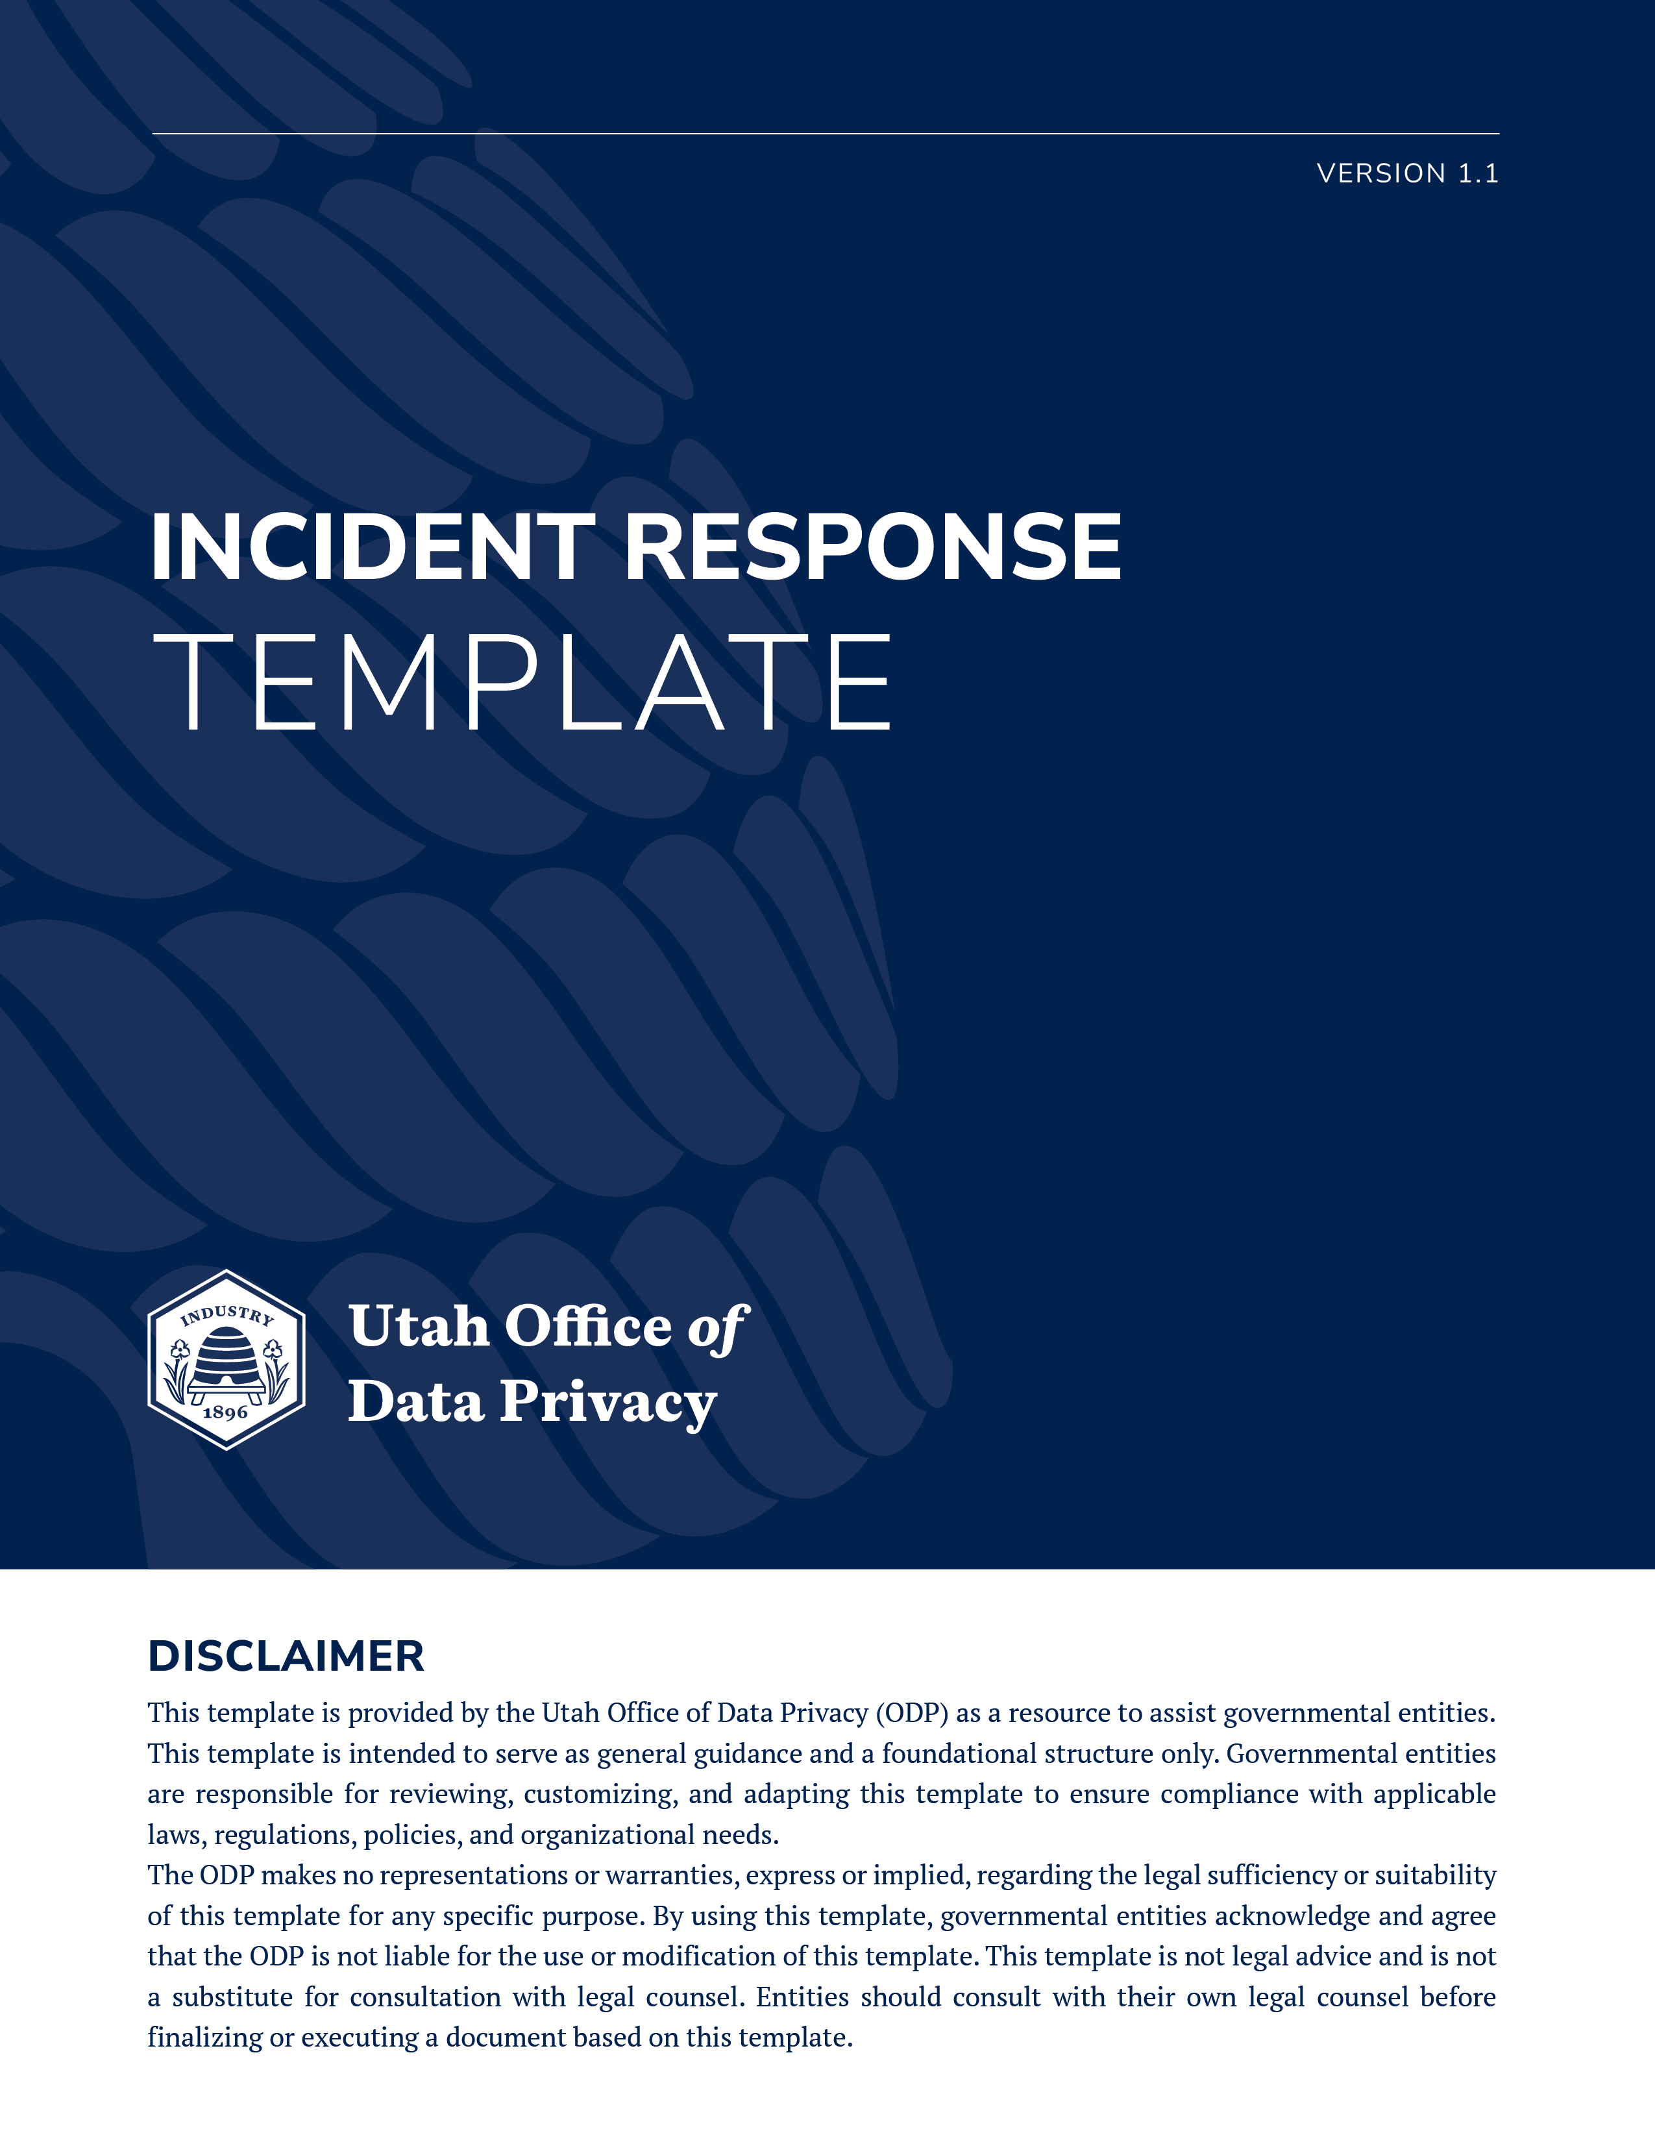
PURPOSE: This template provides a structured framework for documenting, investigating, and reporting security incidents. It is divided into Part 1 – Statutorily Required and Part 2 – Best Practice (NIST 800-61).

PART 1 – STATUTORILY REQUIRED INFORMATION
(Fields REQUIRED under state statute and Cyber Center guidance; must be completed consistently)
INCIDENT IDENTIFICATION
Incident Name/ID:
Date & Time Incident Occurred:
Date & Time Incident Discovered:
Short Description of Incident:
Provide a concise summary of what happened, e.g., type of incident, systems affected, and immediate impact.

ACCESS AND PERPETRATOR DETAILS
Means of Unauthorized Access:
Explain how the incident occurred (e.g., stolen credentials, phishing, malware, email misdelivery).
Person(s) Responsible (if known):

IMPACT
Total Number of Individuals Affected:
Type(s) of Personal Data Compromised:
Examples: Social Security numbers, data classification, financial account information, health data, driver’s license numbers.

MITIGATION STEPS
Actions Taken to Contain or Mitigate Incident:
List immediate actions, e.g., system isolation, password resets, patching vulnerabilities.

PART 2 – BEST PRACTICE
(Recommended fields from NIST 800-61. Other considerations include: HIPAA, FTI, CJIS, PCI-DSS)

INCIDENT CLASSIFICATION AND CONTEXT
Incident Category/Type:
Unauthorized access, malware, phishing, denial-of-service, insider threat, etc.
Incident Severity/Impact Level:
Low, Moderate, High, Critical – based on operational or data impact
Systems, Networks, or Data Repositories Affected:
Incident Source & Indicators (if known):
Include attacker IPs, domains, malicious files, or vectors used

DETECTION & ANALYSIS DOCUMENTATION
Detection Method:
How was the incident first identified (alert, log review, user report, automated tool)?
Logs, Alerts, and Evidence Collected:
Initial Scope & Impact Assessment:
Triage & Prioritization Rationale:
Timeline of Detection and Reporting Events:

Event | Date/Time | Responsible Party | Notes

RESPONSE ACTIONS & TACTICS
Immediate Containment Steps Taken:
Threat Eradication Steps:
Recovery Activities Performed:
Evidence Preservation Methods:
Document chain-of-custody, forensic copies, system snapshots
Tools/Techniques Used in Response:

COMMUNICATION & COORDINATION
Internal Notifications:
Roles notified (i.e. Cyber Center, AG Office etc.), time of notice, method of communication
External Notifications:
Law enforcement, regulators, partners – include dates and contacts
Communication Protocols Used:
Escalation Procedures Followed:

POST-INCIDENT REVIEW & CONTINUOUS IMPROVEMENT
Root Cause Analysis Summary:
Lessons Learned:
Long-term Corrective Actions & Improvements:
Policy, Control, or System Changes to Prevent Recurrence:
Training/Awareness Actions Generated from Incident:

METRICS & REPORTING DATA
Incident Handling Timeline:
Record times for detection, containment, eradication, recovery
Impact on Operations and Services:
Cost and Resource Metrics (if applicable):

INSTRUCTIONS FOR USE:
- Link statutory obligations
- Link Cyber Center Reporting Portal
- Link internal procedure
- Link additional investigation resources
(i.e. Attestation of Destroyed Data, Incident Response Team, Notice of Breach etc.)

