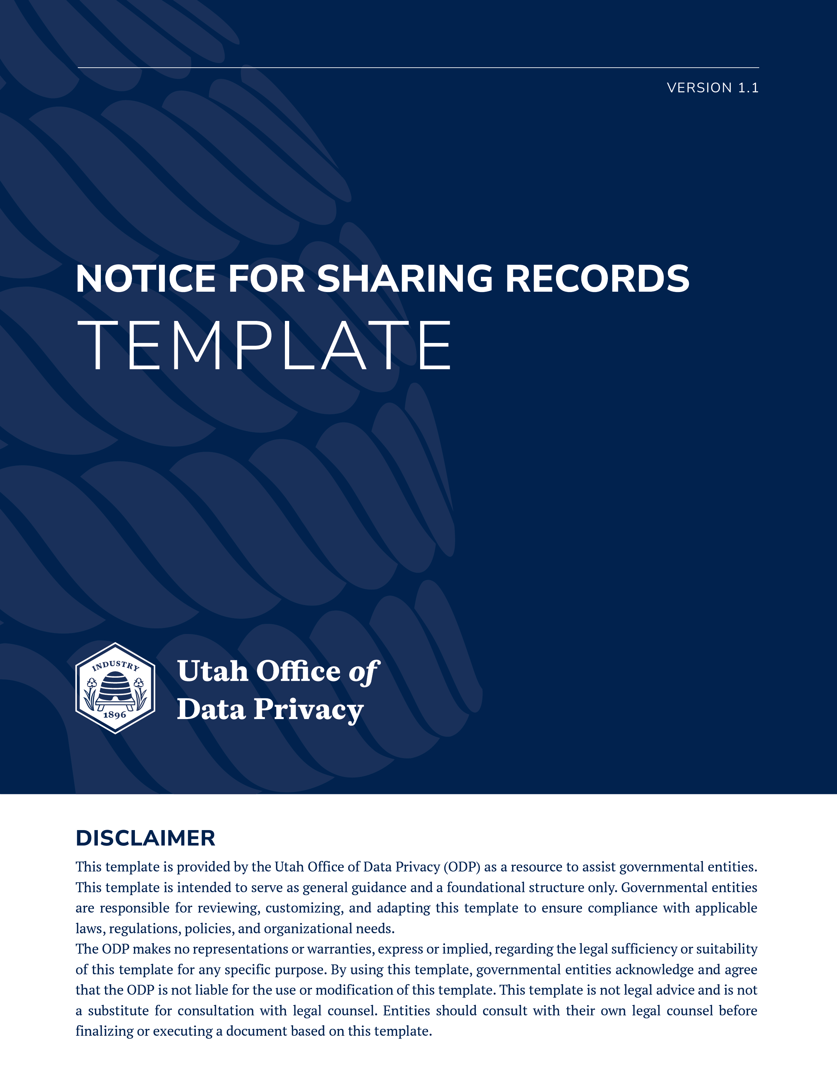

NOTICE FOR SHARING RECORDS
The sharing provisions in GRAMA at Utah Code § 63G-2-206(4) provide that before an originating entity may disclose a record to another governmental entity, another state, the United States, a foreign government, or a contractor or private provider, the originating governmental entity must inform the receiving entity of the record's classification and the accompanying restrictions on access. There may also be other circumstances where the originating entity must obtain written assurances.

The following template is designed for situations where the originating entity provides a single record or records on an ad hoc basis. A governmental entity should ensure that any notice provided fits their particular situation. This notice may be included in an email when sending requested records or in a cover letter.

The attached records are hereby provided to you in response to your request for [describe the records that were requested]. These records are provided to you pursuant to the sharing provisions in the Governmental Records Access and Management Act (GRAMA) at Utah Code § 63G-2-206. These records are classified as [describe the classification of the record and the statute that describes the classification]. These records may not be further disclosed or disseminated as described in Utah Code § 63G-2-204(2).

If an originating entity regularly shares electronic records with a receiving entity, the governmental entities should consider entering into a data sharing agreement (DSA). A DSA describes how the records will be provided, who may have access to the records, how the records may be used, and how the records will be protected. A DSA template is available on the Office of Data Privacy’s website.

