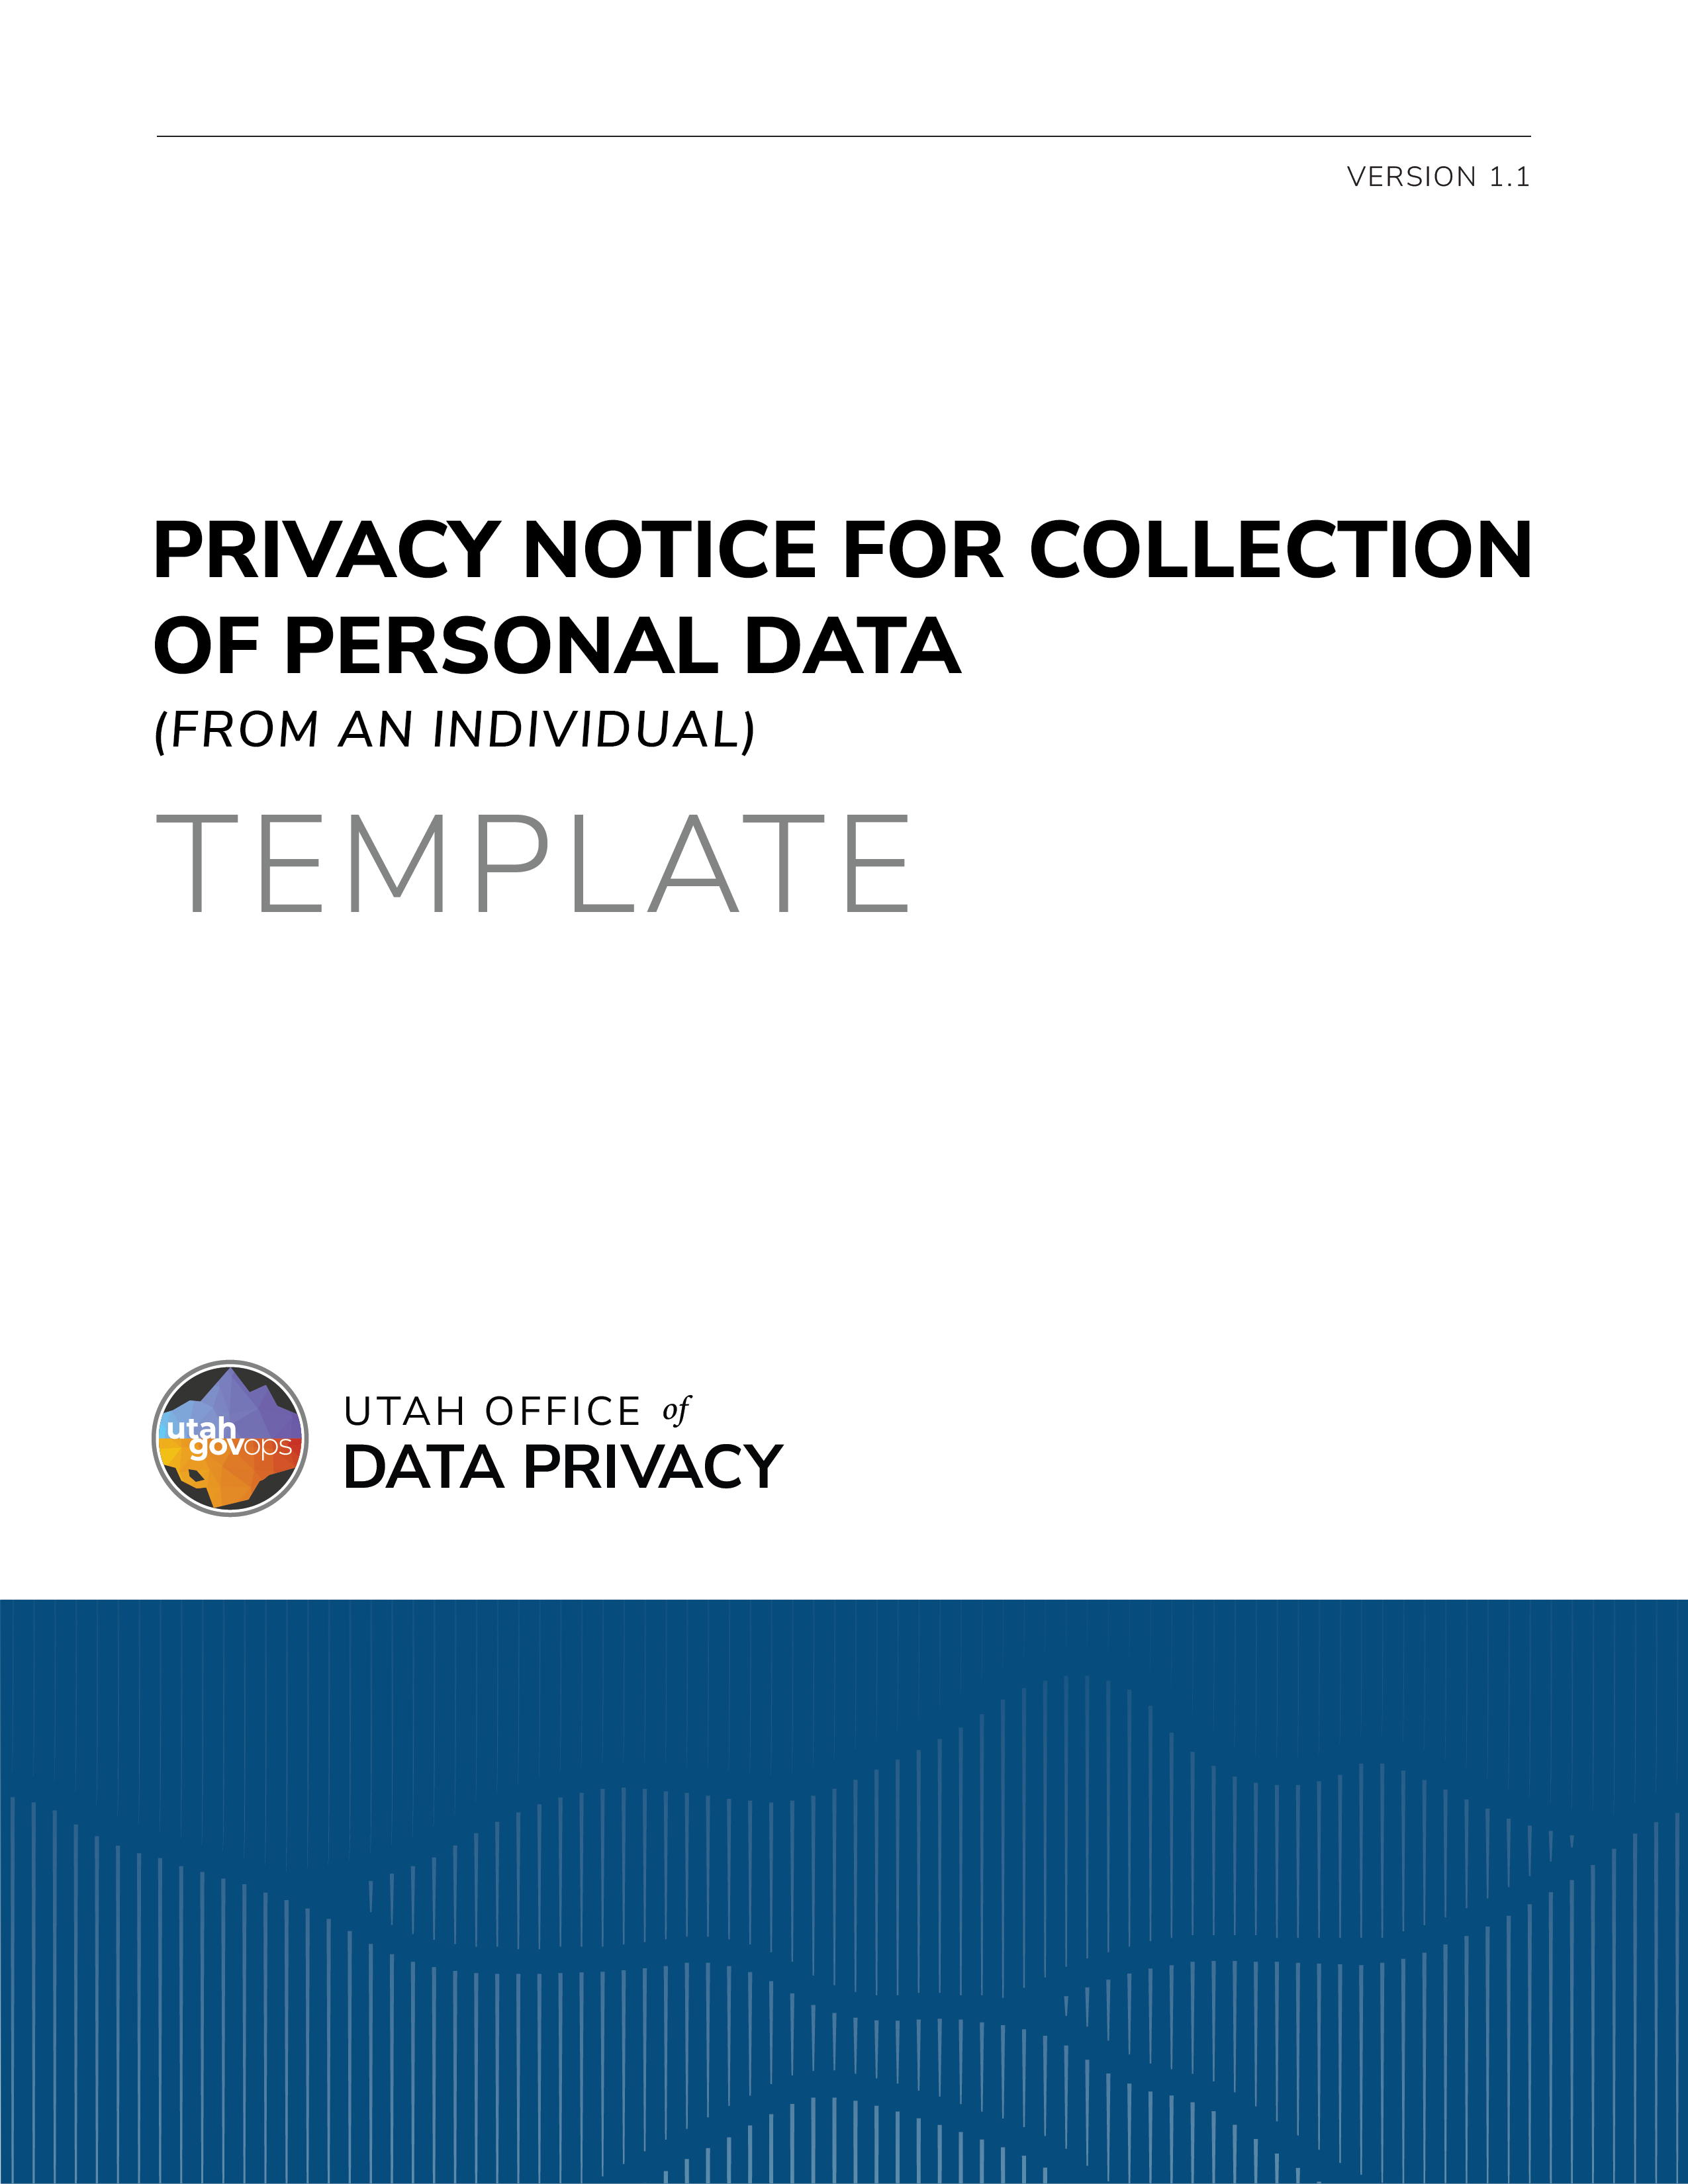

DISCLAIMER
The following document is intended to be a draft template of a privacy notice for personal data collection that a governmental entity may use as a baseline in creating its own privacy notice for personal data collection. Separate language for when personal data that is collected would be classified as a public record and for when personal data would not be classified as a public record is provided. An entity that uses the template must revise and refine the template to be specific to the particular entity; this includes reformatting and accounting for any relevant laws, regulations, rules, policies, etc. to which the entity may be subject. The template is not legal guidance and should be reviewed and discussed with an entity’s legal counsel to determine applicability and compliance.

TEMPLATE OPTION 1 – LIST FORM

(Recommended for complex activities)

Utah Code §§ 63A-19-402 and 63G-2-601.

If the personal data collected would be classified as a public record under Section 63G-2301:
Privacy Notice
The personal data that you provide, or that is collected from you, to [Enter Purpose, ex: sign-up for a virtual workshop, attend an event, etc.] is classified as a public record pursuant to Utah Code § 63G-2-301, of the Government Records Access and Management Act (GRAMA), and may be made available to the public as provided by Utah Code § 63G-2-201.

If the personal data collected would not be classified as a public record:
Privacy Notice
This Privacy Notice is meant to help you understand what personal data is collected, why the personal data is collected, and how you can manage your personal data.

Purposes and Uses for Your Personal Data
We collect the personal data you provide for the following purposes:
- [List all purposes for collecting the personal data. The following are only some examples to consider where applicable.]
- To provide … [action/activity/service/etc.].
- Data analytics …
- To keep you informed about the … [action/activity/service/etc.].
- Security and integrity …
Uses of your personal data include:
- [List all uses for the personal data. The following are some examples to consider.]
- Verification of eligibility to … [ex: attend a virtual training or workshop].
- Registration confirmation, workshop updates, and communication.
- Record-keeping and to ensure the training material is tailored appropriately.
- Ensuring the site is secure and aligns with internal policies.

Sharing and Selling of Personal Data
The classes of persons and entities with whom the [entity] shares personal data includes:
- [List all classes of persons and entities the entity shares the personal data with. The following are only some examples to consider if applicable.]
- Personal data is shared with other governmental entities in accordance with governing law.
- Personal data may be shared with other governmental entities and third-party contractors for the provision of …
- Personal data is shared only when required by law.
- …
The classes of persons and entities to whom the [entity] sells personal data includes:
- [List of classes of persons and entities the entity sells the personal data to. If the personal data is not sold, state so.]
- …
- Your personal data is never sold by [entity].

Record Series
The personal data collected by this form is included in Record Series # ___________. (hyperlink)

Refusal to Provide Personal Data
If you choose not to provide the personal data requested on this form, [describe consequences. Ex: you must contact the [entity] for information on how to use physical documents…]

(Optional)
For more information, please refer to our Website Privacy Notice located here (hyperlink).

TEMPLATE OPTION 2 – PARAGRAPH FORM

(Recommended for simple activities)
Section 63A-19-402 & 63G-2-601
(Note: The privacy notice should be a statement that indicates the following)

If the personal data collected would be classified as a public record under Section 63G-2-301:

The personal data collected on this form, is classified as a public record and may be made available to the public as provided by Utah Code § 63G-2-201.

If the personal data collected is not classified as a public record:

The personal data collected on this form is used for the purpose of (describe the intended purposes and uses of the personal data). If you fail to provide this personal data, (describe the consequences of refusing to provide the personal data). Your personal data may be shared with (describe the classes of persons and governmental entities with whom the ODP shares personal data). Your personal data is/is not sold to (if personal data is sold, describe the classes of persons and governmental entities to whom personal data may be sold, if personal data is not sold, indicate that personal data is not sold). Your personal data collected by this form is included in Record Series # _________ (include hyperlink).

"Personal data" means information that is linked or can be reasonably linked to an identified individual or an identifiable individual. Utah Code § 63A-19-101(24)
"Record series" means a group of records that may be treated as a unit for purposes of designation, description, management, or disposition. Utah Code § 63G-2-103(26) (2024)

