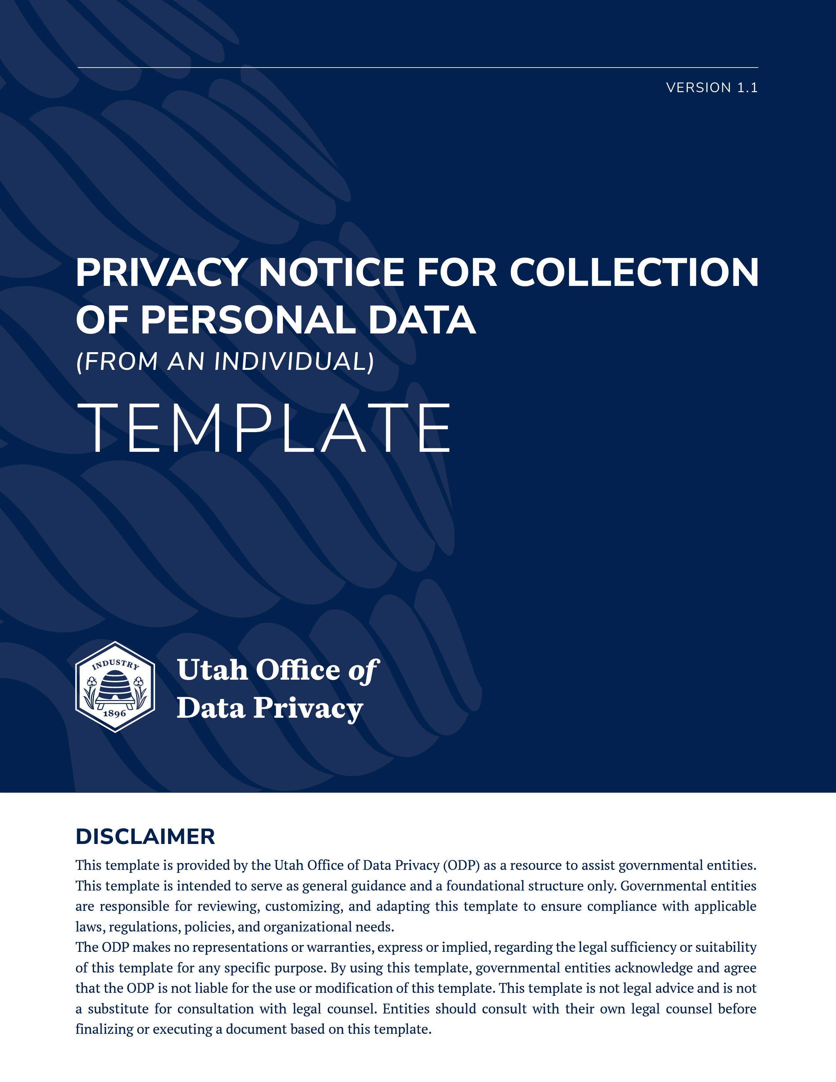

COLLECTION OF PERSONAL DATA CLASSIFIED AS A PUBLIC RECORD
If the personal data collected is classified as a public record, the privacy notice should be limited to a statement indicating:

The personal data collected by this form is classified as a public record pursuant to Utah Code § 63G-2-301, of the Government Records Access and Management Act (GRAMA), and may be made available to the public as provided by Utah Code § 63G-2-201.

COLLECTION OF PERSONAL DATA THAT IS NOT CLASSIFIED AS A PUBLIC RECORD
If the personal data collected is not classified as a public record, the privacy notice must include all of the information described below.

I. PURPOSES AND USES
We process your personal data for the purpose of (list all of the purposes for which personal data is collected).

II. REFUSAL TO PROVIDE PERSONAL DATA
If you do not provide the personal data requested by this form, (describe consequences).

III. SHARING AND SELLING PERSONAL DATA
Your personal data may be shared with (describe the classes of persons and entities with whom the personal data is shared).
Your personal data may be sold to (describe the classes of persons and entities to whom personal data may be sold).
or
Your personal data is never sold.

IV. RECORD SERIES
The personal data collected by this form is included in Record Series # __________ (hyperlink).

