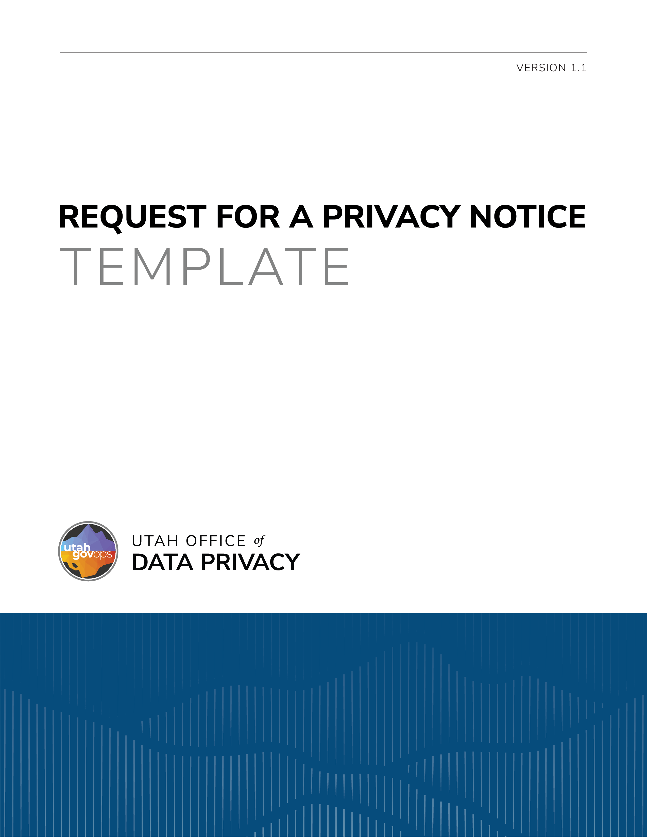

DISCLAIMER
This template is provided by the Utah Office of Data Privacy (ODP) as a resource to assist governmental entities. This template is intended to serve as general guidance and a foundational structure only. Governmental entities are responsible for reviewing, customizing, and adapting this template to ensure compliance with applicable laws, regulations, policies, and organizational needs.
The ODP makes no representations or warranties, express or implied, regarding the legal sufficiency or suitability of this template for any specific purpose. By using this template, governmental entities acknowledge and agree that the ODP is not liable for the use or modification of this template. This template is not legal advice and is not a substitute for consultation with legal counsel. Entities should consult with their own legal counsel before finalizing or executing a document based on this template.

REQUEST FOR A PRIVACY NOTICE

Utah Code §§ 63A-19-402 & 63G-2-601
If requested, a governmental entity must provide a privacy notice to an individual regarding personal data previously furnished by that individual. This privacy notice must describe all intended purposes and uses of the personal data, the consequences for refusing to provide the personal data, who personal data is shared with or sold to, and the record series in which the personal data is included. If requested, a governmental entity must also explain the reason why an individual is asked to furnish information that could be classified as a private or controlled record, the intended uses of the information, the consequences for refusing to provide the information, and how the information may be shared.
Any personal data provided on or with this form will be used for the purpose of processing this request. If the personal data requested by this form is not provided, this request may not be granted. Personal data provided may be shared within the governmental entity to process the request, but it will not be sold. The personal data is included in Record Series # (include the number of the record series and a hyperlink).

Applicant’s name:
Address:
Email:
Phone number:

Describe the personal data or information you previously provided for which you are requesting a privacy notice:

Dated:
Signature of applicant:

Utah Code § 63A-19-402(6).
Utah Code § 63A-19-402(2)(b).
Utah Code § 63G-2-601(3).

