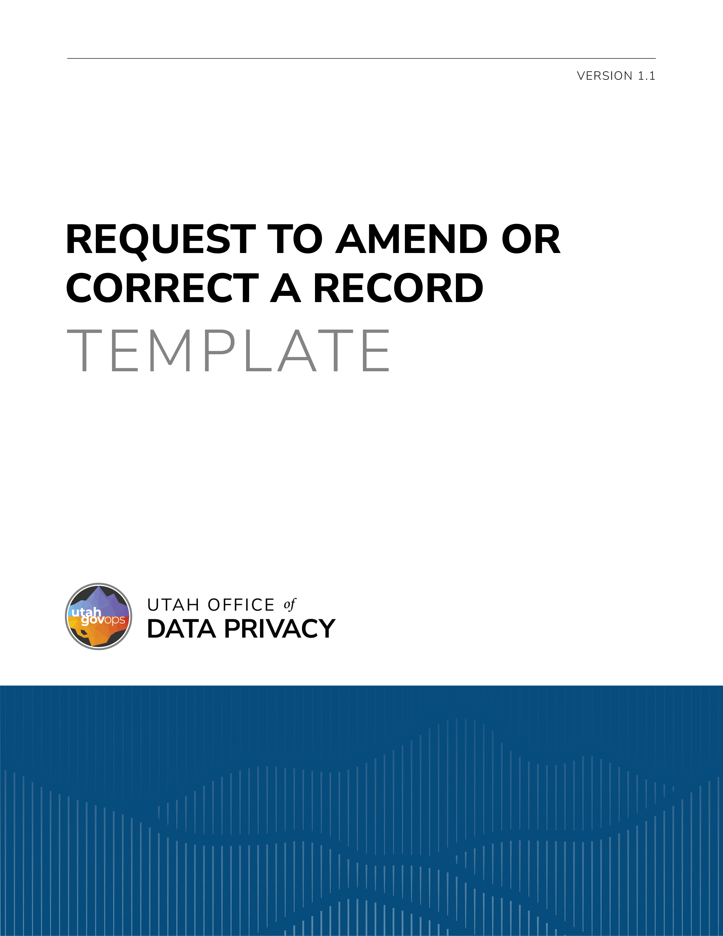

DISCLAIMER
This template is provided by the Utah Office of Data Privacy (ODP) as a resource to assist governmental entities. This template is intended to serve as general guidance and a foundational structure only. Governmental entities are responsible for reviewing, customizing, and adapting this template to ensure compliance with applicable laws, regulations, policies, and organizational needs.
The ODP makes no representations or warranties, express or implied, regarding the legal sufficiency or suitability of this template for any specific purpose. By using this template, governmental entities acknowledge and agree that the ODP is not liable for the use or modification of this template. This template is not legal advice and is not a substitute for consultation with legal counsel. Entities should consult with their own legal counsel before finalizing or executing a document based on this template.

REQUEST TO AMEND OR CORRECT A RECORD

Utah Code §§ 63A-19-403 & 63G-2-603
An individual may request an amendment or correction of personal data furnished to a governmental entity. An individual may also contest the accuracy or completeness of any public, private, or protected record concerning the individual by requesting the governmental entity amend the record.
Any personal data provided on or with this form will be used for the purpose of processing this request. If the personal data requested by this form is not provided, this request may not be granted. Personal data provided may be shared within the governmental entity to process the request, but it will not be sold. The personal data is included in Record Series # (include the number of the record series and a hyperlink).

An individual may request an amendment or correction of personal data furnished to a governmental entity. An individual may also contest the accuracy or completeness of any public, private, or protected record concerning the individual by requesting the governmental entity amend the record.
Any personal data provided on or with this form will be used for the purpose of processing this request. If the personal data requested by this form is not provided, this request may not be granted. Personal data provided may be shared within the governmental entity to process the request, but it will not be sold. The personal data is included in Record Series # (include the number of the record series and a hyperlink).

Applicant’s name:
Address:
Email:
Phone number:
Describe the personal data/record you are asking to be amended (attach a copy if feasible):

Explain why you believe the personal data/record should be amended or corrected:

Dated:
Signature of applicant:

APPROVAL/DENIAL OF REQUEST TO AMEND OR CORRECT

Your request to have personal data/records be amended or corrected has been granted.
Your request to have personal data/records be amended or corrected is denied because:

If your request is denied, you may submit a written statement contesting the information in the record. Your statement will be filed with the disputed record or be made accessible with the record depending on the format of the record. Your statement will be disclosed along with the information in the record whenever the disputed information is disclosed. You may appeal the denial of your request as provided in the Administrative Procedures Act found at Utah Code § 63G-3-101 et seq. or to district court.

Utah Code § 63A-19-403.
Utah Code § 63G-2-603.
Utah Code § 63A-19-403.
Utah Code § 63G-2-603.

