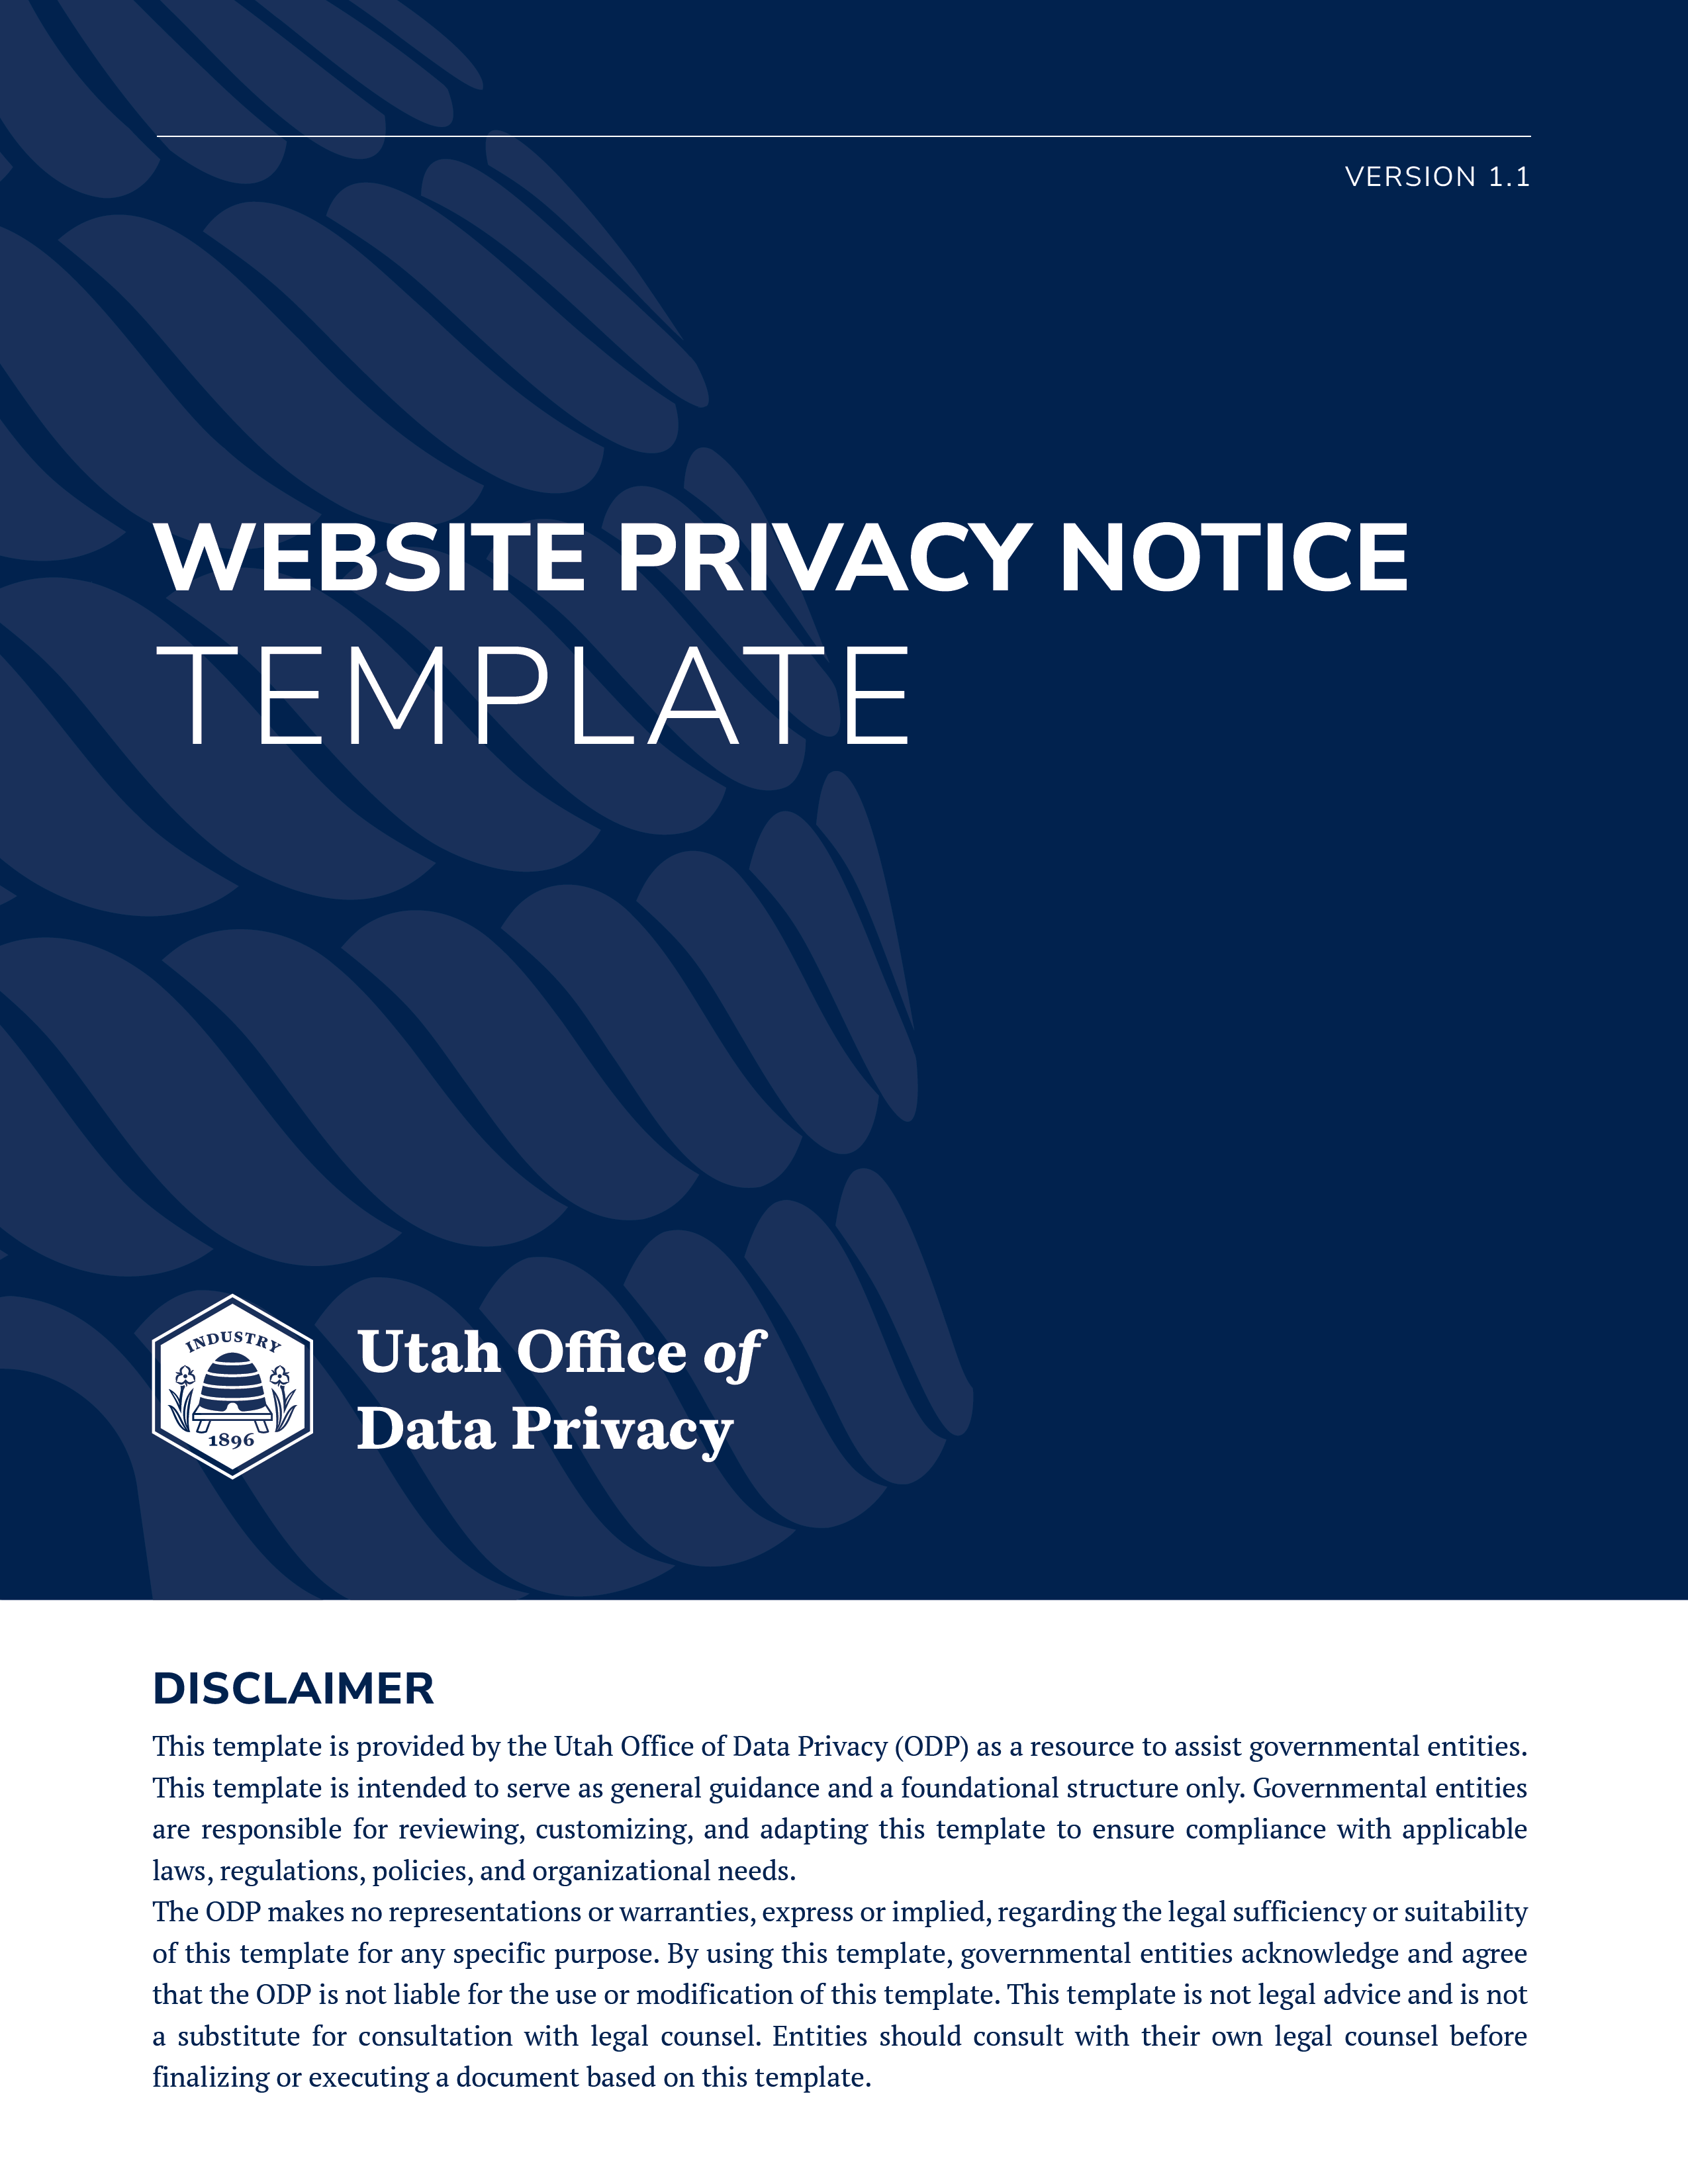

WEBSITE PRIVACY NOTICE

Utah Code § 63A-19-402.5
The website privacy notice or a link to a separate webpage containing the notice should be prominently posted on the homepage of the government website.

I. GOVERNMENT WEBSITE OPERATOR
(Name of governmental entity) is responsible for this website and may be contacted by:
• Telephone:
• Email:

II. PRIVACY RIGHTS
By contacting the (name of governmental entity) you may:
• seek access to your personal data or user data;
• request to correct or amend your personal data or user data; and
• if you are an at-risk employee, request that your personal data be classified as a private record.
You may also contact the Data Privacy Ombuds at privacyombudsperson@utah.gov.
If the website uses website tracking technology to collect user data, the website privacy notice must also include the following information.

IV. USER DATA COLLECTED
This website uses the following website tracking technology to collect user data (describe any website tracking technology used).
The user data that is collected when you access this website includes (describe types of user data collected).

V. PURPOSES AND USES
(Name of governmental entity) processes your user data for the following purposes (describe intended purposes of the user data).

VI. SHARING AND SELLING USER DATA
Your user data may be shared with (describe the classes of persons and entities with whom user data is shared).
Your user data may be sold to (describe the classes of persons and entities to whom user data is sold).
or
Your user data is never sold.

VII. RECORD SERIES
The user data collected by this website is included in Record Series # __________
(hyperlink).

“Personal data” means information that is linked or can be reasonably linked to an identified individual or an identifiable individual.
“User data” means any information about a user that is automatically collected by a government website when a user accesses the government website and includes information that identifies: • a user as having requested or obtained specific materials or services from a government website; • Internet sites visited by a user; • the contents of a user's data-storage device; • any identifying code linked to a user of a government website; and • a user's: • IP or Mac address; or • session ID.
“At-risk government employee” means a current or former: • peace officer as specified in Section 53-13-102; • state or federal judge of an appellate, district, justice, or juvenile court, or court commissioner; • judge authorized by Title 39A, Chapter 5, Utah Code of Military Justice; • judge authorized by Armed Forces, Title 10, United States Code; • federal prosecutor; • prosecutor appointed pursuant to Armed Forces, Title 10, United States Code; • law enforcement official as defined in Section 53-5-711; • prosecutor authorized by Title 39A, Chapter 5, Utah Code of Military Justice; or • state, federal, or local government employee who, because of the unique nature of the employee's regular work assignments or because of one or more recent credible threats directed to or against the employee, would be at immediate and substantial risk of physical harm if the employee's personal information is disclosed.
“Website tracking technology” means any tool used by a government website to monitor a user's behavior or collect user data.

