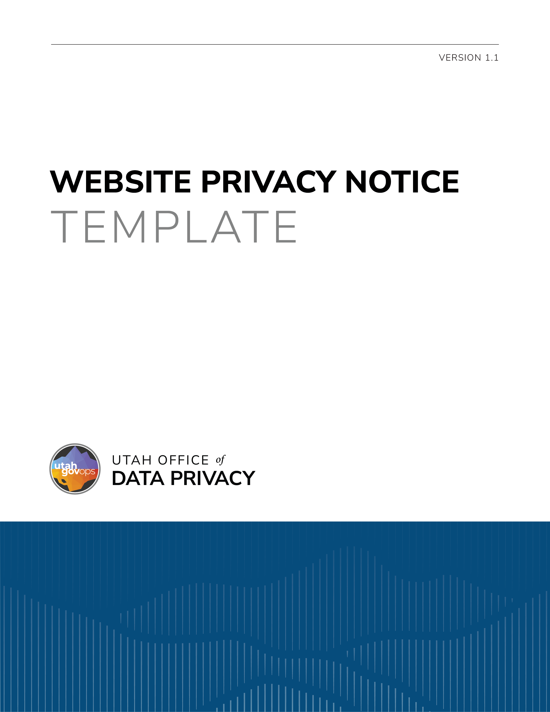

DISCLAIMER
The following document is intended to be a draft website privacy notice template that a governmental entity may use as a baseline in creating its own website privacy notice. An entity that uses the template must revise and refine the template to be specific to the particular entity; this includes reformatting and accounting for any relevant laws, regulations, rules, policies, etc. The template is not legal guidance and should be reviewed and discussed with an entity’s legal counsel to determine applicability and compliance. See Utah Code § 63A-19-402.5.

TEMPLATE OPTION 1 – LIST FORM
*(The website privacy notice or a link to a separate webpage containing the notice should be prominently posted on the homepage of the government website.)

WEBSITE PRIVACY NOTICE
[Name of governmental entity] is committed to protecting the privacy of individuals who access its websites. The notice informs those accessing [name of governmental entity] websites about what user data¹ is collected, why it is collected, and how they can update and manage personal data² or user data.

I. Website Operational Information
The [name of governmental entity] is responsible for this website.
The [name of governmental entity] may be contacted by:
Telephone: [contact info of the governmental entity as applicable]
Email: …

II. Individual’s Personal Data and User Data
By contacting the [name of governmental entity] an individual may:
- seek access to the individual’s personal data or user data;
- request to correct or amend the individual's personal data or user data; or
- if the individual qualifies as an at-risk employee³, request that the individual’s personal data be classified as a private record.

III. Data Privacy Ombudsperson
An individual may contact the Data Privacy Ombudsperson to file a complaint about a privacy practice of a governmental entity by using the following contact information:
Email: privacyombudsperson@utah.gov

*(If the website collects user data, the website privacy notice should also include the following information.)

IV. Website User Data
This website may use website tracking technology⁴ to collect user data. Website tracking technology used on this website includes:
- [List/describe any website tracking technology used]

- …

User data collected on this website includes:
- [List/describe types of user data collected]

- …

V. Purposes and Uses for User Data
The [name of governmental entity] collects user data for the following purposes:
- [List/describe intended purposes of the user data]
- …
Uses of user data include:
- [List/describe intended uses of the user data]
• …

VI. Sharing and Selling of User Data
The classes of persons and entities with whom the [name of governmental entity] shares user data includes:
- [List/describe the classes of persons and entities with whom user data is shared]

- …
The classes of persons and entities to whom the [name of governmental entity] sells user data includes:
- [List/describe the classes of persons and entities to whom user data is sold]

- …

VII. Record Series
The user data collected on this website is included in Record Series #___________ (Include hyperlink)

TEMPLATE OPTION 2 – PARAGRAPH FORM
*(The website privacy notice or a link to a separate webpage containing the notice should be prominently displayed on the homepage of the government website. Depending on how an entity decides to provide the website privacy notice—either on the homepage or a link to a separate webpage—the following language should be revised accordingly.) See Utah Code § 63A-19-402.5.

The [name of governmental entity] is committed to protecting your privacy. To find out more about your privacy interests and what user data may be collected when you visit this website, click here: (include a link to a separate webpage with the website privacy notice).

Website privacy notice listed on separate webpage, as applicable:

WEBSITE PRIVACY NOTICE

This website is operated by the [name of governmental entity]. You may contact the [name of governmental entity] at [contact info for the governmental entity]. By contacting the [name of governmental entity] you may:
- access your personal data^{i} or your user data^{ii};
- request to correct or amend your personal data or user data; or
- if you qualify as an at-risk employee^{iii}, request that your personal data be classified as a private record.
If you are concerned with the data privacy practices of a governmental entity, you may file a complaint with the Data Privacy Ombudsperson by sending an email to privacyombudsperson@utah.gov.

*(If the website collects user data, the website privacy notice should also include the following information.)
This website uses (describe the website tracking technology^{iv} used) to collect (describe type of user data). This user data is used to (describe the intended purposes and uses of the user data). Your user data may be shared with (describe the classes of persons and governmental entities with whom the user data is shared with). Your user data is/is not sold to (describe the classes of persons and governmental entities to whom the user data is sold, if user data is not sold indicate that user data is not sold). The user data collected is included in Record Series # _________ (include hyperlink).

¹ "User data" means any information about a user that is automatically collected by a government website when a user accesses the government website.
(b) "User data" includes information that identifies:
(i) a user as having requested or obtained specific materials or services from a government website; (ii) Internet sites visited by a user;
- the contents of a user's data-storage device;
- any identifying code linked to a user of a government website; and (v) a user's:
- IP or Mac address; or
- session ID. (Utah Code § 63A-19-101(38)(a) and (b)).
² "Personal data" means information that is linked or can be reasonably linked to an identified individual or an identifiable individual. (Utah Code § 63A-19-101(24)).
- (a) "At-risk government employee" means a current or former:
  - peace officer as specified in Section 53-13-102;
  - state or federal judge of an appellate, district, justice, or juvenile court, or court commissioner;
  - judge authorized by Title 39A, Chapter 5, Utah Code of Military Justice;
  - judge authorized by Armed Forces, Title 10, United States Code;
  - federal prosecutor;
  - prosecutor appointed pursuant to Armed Forces, Title 10, United States Code;
  - law enforcement official as defined in Section 53-5-711;
  - prosecutor authorized by Title 39A, Chapter 5, Utah Code of Military Justice; or
  - state or local government employee who, because of the unique nature of the employee's regular work assignments or because of one or more recent credible threats directed to or against the employee, would be at immediate and substantial risk of physical harm if the employee's personal information is disclosed. (Utah Code § 63G-2-303(1)(a)).
- (39) “Website tracking technology” means any tool used by a government website to:
    - monitor a user’s behavior; or
    - collect user data. (Utah Code § 63A-19-101(39)).
- "Personal data" means information that is linked or can be reasonably linked to an identified individual or an identifiable individual. (Utah Code § 63A-19-101(24)).
- "User data" means any information about a user that is automatically collected by a government website when a user accesses the government website. (Utah Code § 63A-19-101(38)).
- "At-risk government employee" means a current or former:
  - peace officer as specified in Section 53-13-102;
  - state or federal judge of an appellate, district, justice, or juvenile court, or court commissioner;
  - judge authorized by Title 39A, Chapter 5, Utah Code of Military Justice;
  - judge authorized by Armed Forces, Title 10, United States Code;
  - federal prosecutor;
  - prosecutor appointed pursuant to Armed Forces, Title 10, United States Code;
  - law enforcement official as defined in Section 53-5-711;
  - prosecutor authorized by Title 39A, Chapter 5, Utah Code of Military Justice; or
  - state or local government employee who, because of the unique nature of the employee's regular work assignments or because of one or more recent credible threats directed to or against the employee, would be at immediate and substantial risk of physical harm if the employee's personal information is disclosed. (Utah Code § 63G-2-303(1)(a)).
- (39) “Website tracking technology” means any tool used by a government website to:
    - monitor a user’s behavior; or
    - collect user data. (Utah Code § 63A-19-101(39)).

