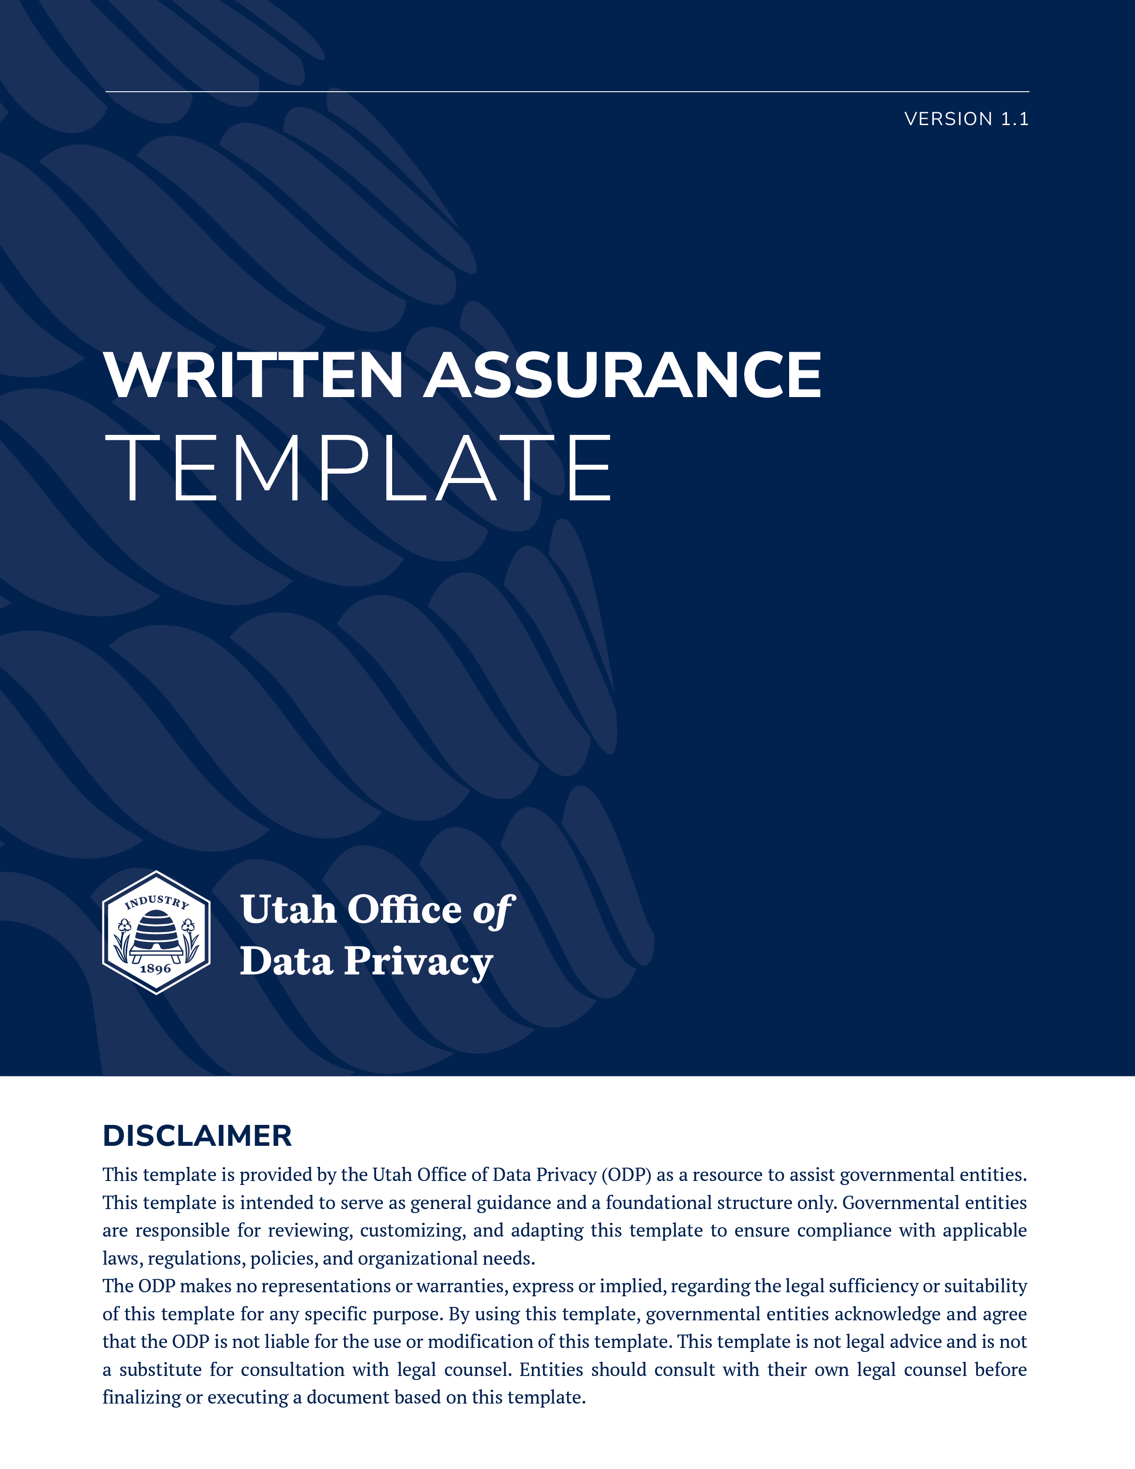

WRITTEN ASSURANCE OF REQUESTING ENTITY
Pursuant to Utah Code § § 63G-2-206(2)

- PARTIES INVOLVED
- Originating Entity: [Name of Governmental Entity]
- Requesting Entity: [Name of Governmental Entity]
- Date of Request: [Date]

DESCRIPTION OF RECORDS
The following records or record series are shared under this agreement:
- Records Requested: [Include a description of the records that were requested and provided, e.g., copies of all police reports related to John Doe, DOB 5/19/67.]
- Record Name/Series: [Insert Name]
- Classification of Record: [Private / Controlled / Protected/Exempt]
- If exempt, cite the applicable statute, rule, or regulation.
- Restrictions on Access: [Who can access the record and for what reason.]

WRITTEN ASSURANCE (Required by Utah Code § 63G-2-206(2)(a))
The Requesting Entity hereby provides the following assurances to the Originating Entity:
- Necessity: The records described above are necessary to the performance of the Requesting Entity’s official duties and functions.
- Similarity of Purpose: The records will be used for a purpose similar to the purpose for which the information was originally collected or obtained by the Originating Entity.
- Public Benefit: The use of the records produces a public benefit that is greater than or equal to the individual privacy right that protects the record or record series.

AGREEMENT TO ABIDE BY RESTRICTIONS (Utah Code § 63G-2-206(4))
As the Recipient of these records, the Requesting Entity acknowledges and agrees to the following:
- Notification of Classification: The Requesting Entity has been informed of the records’ classification and the accompanying restrictions on access.
- Duty to Comply: The Requesting Entity shall abide by all restrictions on access as defined by the Originating Entity.
- Secondary Disclosure: The Requesting Entity may not disclose or disseminate these records as provided by Utah Code § 63G-2-204(2). If the Requesting Entity receives a records request for these records, the Requesting Entity shall deny the records request and refer the person making the request to the Originating Entity.

EXECUTION AND SIGNATURES
FOR THE REQUESTING ENTITY:
Signature: __________________________
Printed Name: [Name]
Title: [Title]
Date: [Date]
FOR THE ORIGINATING ENTITY (ACKNOWLEDGMENT OF DISCLOSURE):
Signature: __________________________
Printed Name: [Name]
Title: [Title]
Date: [Date]

